Cycle 8: 25th November to 23rd December, 2021
Subject: Psychology
Class XI

Chapter 3: Sensory, Attentional & Perceptual Processes

Main Highlights
- Sensation, Perception and Attention, Chapter 5 for Psychology Class 11 addresses three main processes that determine the way we gain knowledge of things happening around the world.
- The initial experience of a stimulus or an object registered by our sense organs is called sensation.
- In the process of attention, we select a certain stimulus from a given set of stimuli.
- Perception is defined as the process by which we interpret the stimuli in our environment and give proper meaning to them.

Functional Limitations Of Sense Organs
- In order to get noticed by a sensory receptor, a stimulus has to be of an optimal intensity or magnitude. The relationship between stimuli and the sensations they evoke is profoundly studied under a discipline called Psychophysics.
- In order to get noticed a stimulus has to carry a minimum value or weight. The minimum value of a stimulus required to activate a given sensory system is termed as Absolute Threshold or Absolute Limen(AL).
- The smallest difference in the value of two stimuli that is necessary to notice them as different is called Difference Threshold or Difference Limen(DL).

Attentional Processes
- In the process of attention, we select a certain stimulus from a given set of stimuli.
- For example, when we enter a mall, we come across so many people, showrooms, cafes but we pay attention to the place where we want to go.
- There are 3 properties of attention described as follows-
  - Alertness refers to the activeness and readiness of an individual to deal with the stimuli that appear before him/her.
  - Concentration refers to focussing awareness on certain Stimuli while excluding others for the moment.
  - In Search, an observer searches for some specified subset of stimuli among a given set of stimuli.
- Attention has a focus where our maximum awareness is catered as well as a fringe where we are least aware of the stimuli.
  - When our awareness is centred on a particular object or event, it is called a focal point of attention.
  - When we have vague ideas about the stimulus and it is away from the centre of awareness, it is called a fringe of attention.

Filter Theory
- It was given by Broadbent (1956). As per this theory, many stimuli enter our receptors which creates a kind of “bottleneck” situation.
- Moving through the short term memory system, they enter the selective filter which allows only one stimulus to pass through for higher levels of attention.

Filter Attenuation Theory
- It was developed by Triesman (1962) and it was considered as a modification of Broadbent’s theory.
- As per this theory, the stimuli not getting access to the selective filter at a given moment of time are not completely blocked, instead, they are just attenuated (weakened) in strength.

Multimode Theory
- It was developed by Johnston and Heinz in 1978. According to the multimode theory, attention is a flexible system that allows the selection of a stimulus over others at three stages
- At stage one sensory representations are constructed, at stage two semantic representations are constructed and in stage three both of them enter our consciousness.

Two Types of Attention & Factors Affecting it

Sustained Attention
While selection of Stimuli focuses on selection of stimuli whereas on the other hand,sustained attention lays emphasis on.It is defined as the ability to maintain attention on an object or event for longer durations

Factors Affecting Sustained Attention
- Sensory Modality: Performance is found to be superior when the stimuli are auditory than when they are visual
- Clarity of Stimuli: Intense and long-lasting stimuli facilitate sustained attention and thus, leading to better performance
- Temporal Uncertainty: Stimuli can be attended better if they appear at regular intervals as in such cases it is easier to keep a track of it.
- Spatial Uncertainty: Stimuli that appear at a fixed place are readily attended whereas those at random places are difficult to attend.

Selective Attention
It is concerned mainly with the selection of a limited number of stimuli or objects from a larger number of stimuli Our perceptual system has a limited capacity to receive and process information.

Factors Affecting Selective Attention
- External factors: It deals with the features of stimuli. Other things held constant, the size, intensity and motion of stimuli appear to be significant determinants of attention. Novel stimuli easily catch our attention.
- Internal factors lie within the individual and are elaborated as follows:
  - Motivational factors which relate to our biological or social needs
  - Cognitive factors include factors like interest, attitude and preparatory set and interesting objects are easily attended by the individuals.

Perceptual Processes
- Perception is defined as the process by which we interpret the stimuli in our environment and give proper meaning to them. Two processing approaches are elucidated as follows-
  - The idea that the process of recognition begins from the parts, which serve as the basis for recognition of the whole is termed as Bottom-Up Processing.
  - The idea that the recognition process begins from the whole, which leads to the identification of its various components is termed Top-Down Processing.
- Human beings are creative and smart in nature who always attempt to give substantial meaning to the stimuli in their environment.
- Factors that play an important role in the perception process are described as follows-
  - Motivation- The needs and desires of a perceiver strongly influence his/her perception and people always aim to satisfy their needs and wants and for that people perceive objects in such a way that it will satisfy their needs and desires.
  - Expectations– The expectations about what we might perceive in a given situation also have a strong impact on our perception and it reflects a strong tendency to see what we expect to see even when the results are not in sync with the external reality.
  - Cognitive Styles- It is defined as the consistent way of dealing with our environment and it crucially affects the way we perceive our environment.
  - Cultural Background And Experiences- Different experiences and learning opportunities available to people available in different cultural settings also has a strong impact on the perception.
- The process of organising visual fields into meaningful wholes is defined as form perception.
- As per Gestalt Psychologists, we perceive different stimuli not as discrete elements but as an organised whole that has a definite form. For Example, a flower pot with a bunch of flowers is a whole and if the flowers are removed, the flower pot still remains a whole.
- The most primitive organisation takes place in the form of figure-ground segregation
Figure | Ground
Figure has a definite form. | backGround is relatively formless.
It is highly organised. | It is highly unorganised.
It has a clear contour. | It is contourless.
Figure stands out from the background. | Background stays behind the figure.
Figure is clearer,limited and relatively nearer. | Background appears relatively unclear,unlimited and away from us.

Laws Of Perceptual Organization
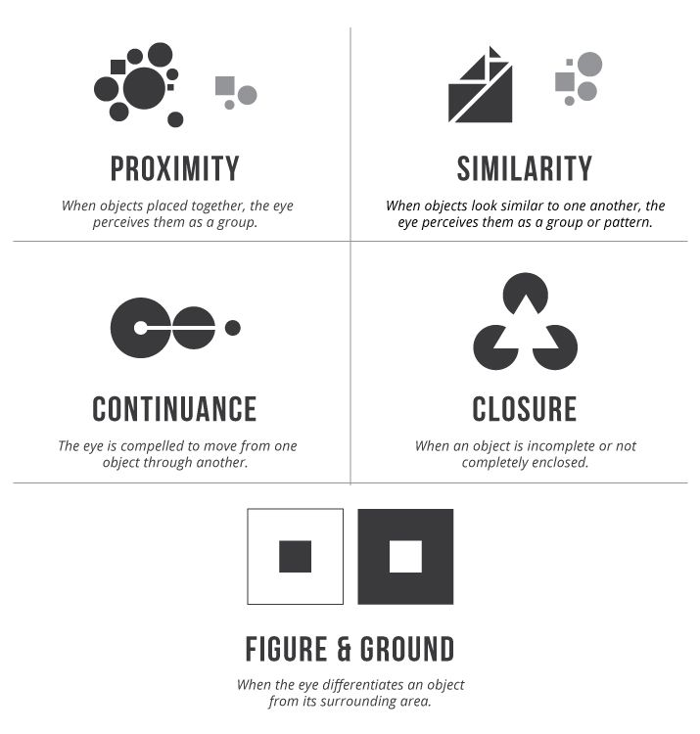
Laws of Perceptual Organization principles are explained below:
- The Principle Of Proximity: According to this principle, the objects that are close together in space or time are perceived together.
- The Principle Of Similarity: According to this principle, objects that are similar to one another and have similar characteristics are perceived as a group
- The Principle Of Continuity: This principle states that we tend to perceive objects as belonging together if they appear to form a continuous pattern.
- The Principle Of Smallness: As per this principle, smaller areas tend to be seen as figures against a larger background.
- The Principle Of Symmetry: This principle suggests that symmetrical areas tend to be seen as figures against asymmetrical backgrounds
- The Principle Of Surroundedness: This principle suggests that areas surrounded by others tend to be perceived as figures.
- The Principle Of Closure: We tend to fill gaps in stimulation and tend to perceive objects as a whole rather than their separate parts.

Perception of Space, Depth and Distance
- The process of viewing the world in three dimensions is termed distance or depth perception
- On perceiving depth, we mainly depend on two main sources of information termed cues.
- One is called Binocular cues as they require both eyes and another is called Monocular cues as they allow us to perceive depth with just one eye
- Monocular cues are explained below–
  - Relative Size: We tend to perceive an object farther away when it appears small, and closer when it appears bigger.
  - Overlapping: These cues occur when some portion of the object is covered by another object. The overlapped object is considered farther away, whereas the object that covers it appears nearer.
  - Linear perspective: Denotes the phenomenon by which distant objects appear to be closer together than nearer objects.
  - Aerial Perspective: The air comprises microscopic particles of dust and moisture that makes distant objects look hazy or blurry. This effect is called Aerial Perspective.
  - Light And Shade: In light, some parts of the object get highlighted, whereas some parts become darker.
  - Relative Height: Larger objects are perceived as being closer to the viewer and smaller objects as being farther away.
  - Texture Gradient: Denotes a phenomenon by which the visual field having more density of elements is seen farther away.
  - Motion Parralox: It is a kinetic monocular cue that occurs when objects at different distances move at a different relative speed.
- Binocular cues (Physiological Cues) are:
  - Retinal or Binocular Disparity: It occurs because the two eyes have different locations in our head. They are separated by each other horizontally by a distance of about 6.5 centimetres and due to the distance, the image formed on the retina of each eye of the same object is slightly different and this is known as retinal disparity.
  - Convergence: When we see a nearby object our eyes converge inward in order to bring the fovea of each eye. A group of muscles send messages to the brain regarding the degree to which eyes are turning inward and these messages are interpreted as cues to the perception of depth. The degree of convergence decreases as the object moved farther away from the observer.

Perceptual Constancies
- Perception of the objects is relatively stable in spite of changes in the stimulation of sensory receptors called perceptual constancy.
- We will now explore three types of Perceptual Constancies
  - Size Constancy: The tendency for the perceived size of objects to remain relatively unchanged with changes in their distance from the observer and the size of the retinal image is called Size Constancy.
  - Shape Constancy: In our perceptions, the shapes of familiar objects remain unchanged despite changes in the pattern of the retinal image resulting from the differences in their orientation.
  - Brightness Constancy: The tendency to maintain an apparent brightness constant under different amounts of illumination is termed brightness Constancy.

Illusions
- They refer to misperceptions which are a consequence of misinterpretation of information received by our sensory organs.
- Some illusions are universal in nature whereas others are more personal and culture-specific.
- Some important visual illusions are as follows-
  - Geometric Illusion
  - Muller-Lyer Illusion
  - Vertical-Horizontal Illusion
  - Apparent Movement Illusion

Socio-Cultural Influence On Perception
- Socio-cultural factors play a crucial role in our perceptions by generating differential familiarity with and salience of stimuli as well as certain habits of Perceptual influence among people.
- People differ in their way of identification of objects and interpretation of depth as per their cultural settings.
******************

