COMPETENCY BASED QUESTIONS

CLASS: X SUBJECT: GEOGRAPHY

CHAPTER 4: AGRICULTURE

PART A

1. Read the source given below and answer the questions that follow:

This type of farming is still practised in few pockets of India. Primitive subsistence agriculture is practised on small patches of land with the help of primitive tools like hoe, dao and digging sticks, and family/community labour. This type of farming depends upon monsoon, natural fertility of the soil and suitability of other environmental conditions to the crops grown. It is a ‘slash and burn’ agriculture. Farmers clear a patch of land and produce cereals and other food crops to sustain their family. When the soil fertility decreases, the farmers shift and clear a fresh patch of land for cultivation. This type of shifting allows Nature to replenish the fertility of the soil through natural processes; land productivity
in this type of agriculture is low as the farmer does not use fertilisers or other modern inputs. It is known by different names in different parts of the country.
- Which one of the following is NOT correct for primitive subsistence farming?
(a) Use of traditional methods
(b) community labour
(c) small plot of land
(d) high land productivity
- Mention any two factors on which this type of farming depends.
- Which crops are grown in slash and burn agriculture?

2. Read the sources given below and answer the questions that follow:

Today, Indian agriculture finds itself at the crossroads. To make agriculture successful and profitable, proper thrust should be given to the improvement of the condition of marginal and small farmers. The green revolution promised much. But today it’s under controversies. It is being alleged that it has caused land degradation due to overuse of chemicals, drying aquifers and vanishing biodiversity. The keyword today is “gene revolution”, which includes genetic engineering.
Infact organic farming is much in vogue today because it is practised without factory made chemicals such as fertilisers and pesticides. Hence, it does not affect environment in a negative manner. A few economists think that Indian farmers have a bleak future if they continue growing foodgrains on the holdings that grow smaller and smaller as the population rises. India’s rural population is about 833 million (2011) which depends upon 250 million (approximate) hectares of agricultural land, an average of less than half a hectare per person. Indian farmers should diversify their cropping pattern from cereals to high-value crops. This will increase incomes and reduce environmental degradation simultaneously. Because fruits, medicinal herbs, flowers, vegetables, bio-diesel crops like jatropha and jojoba need much less irrigation than rice or sugarcane. India’s diverse climate can be harnessed to grow a wide range of high-value crops.

- What are the negative impacts of green revolution?
- Mention any two steps that should be taken to improve the agricultural income.

PART B

- Which one of the following is NOT true for pulses?
(a) Pulses are grown in both rabi and kharif season
(b) Pulses are leguminous crops
(c) They are grown in rotation with other crops
(d) Pulses require intensive irrigation facilities

- Which of the following describes a system of agriculture, where a single crop is grown on a large area?
(a) Shifting agriculture
(b) Plantation agriculture
(c) Horticulture
(d) Intensive agriculture
- Look at the given picture carefully and answer the questions that follow:
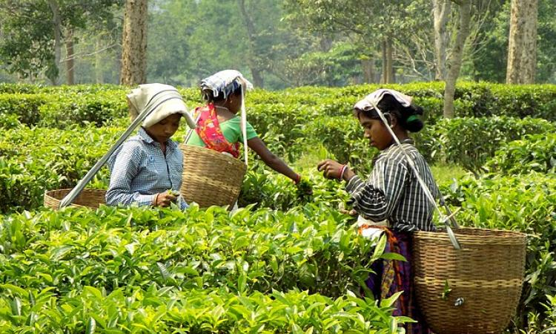
(i) What are these women engaged in?
(ii) Name the states where it is grown.

- Coffee cultivation was first introduced in:
- Himalayas
- Aravali Hills
- Garo Hills
- Baba Budan Hills

- Match the items of column A with that of column B.
Column A Column B
- Sugarcane (I) West Bengal
- Cotton (II)Kerala
- Jute (III) Uttar Pradesh
- Rubber (IV) Maharashtra
Answer:
- (A)-(II), (B)-(IV), (C)-(I), (D)-(III)
- (A)-(IV), (B)-(III), (C)-(II), (D)-(I)
- (A)-(III), (B)-(IV), (C)-(I), (D)-(II)
- (A)-(I), (B)-(III), (C)-(II), (D)-(IV)

- Given below are some conditions/factors required for the growth of tea crops in India except one. Find it out.
- Tea is a labour intensive industry.
- It requires warm and moist free climate all through the year.
- It grows well in tropical and sub tropical climates.
- It is a beverage crop introduced by the British in India.

- Why is there enormous pressure on agricultural land in India? Choose the correct option:
- Landholding size is very small.
- High doses of biochemical inputs are used in agriculture.
- Degree of commercialisation of agriculture varies from one region to another.
- Farmers with small landholdings are not able to afford the right techniques of farming.

- Assertion (A): The growth rate in agriculture has been decelerating which is an alarming situation.
Reason (R): Today, Indian farmers are facing a big challenge from international competition and reduction in the public investment in agriculture sector

(a) Both (A) and (R) are true, and (R) is the correct explanation of (A).
(b) Both (A) and (R) are true, but (R) is not the correct explanation of (A).
(c) (A) is true but (R) is false.
(d) (A) is false but (R) is true.
- Identify the crop with the help of the given information.

- It is a crop which is used both as food and fodder.
- It is a kharif crop which requires temperature between 21°C to 27°C and grows well in old alluvial soil.
- In some states like Bihar it is grown in rabi season also.

****************

