COMPETENCY BASED QUESTION
Revision for Half-yearly Examination
CLASS- XII
MULTIPLE CHOICE Questions ( 1 MARK )
- Assertion – (A) – NAM gave the members right not to choose any bloc over the other and yet gave them the right to deal with the global issues.
Reason – (R) – Jawaharlal Nehru isolated India from the rest of world.
- Both A and R are true and R is the correct explanation of A.
- Both A and R are true, but R is not the correct explanation of A.
- A is true but R is false
- A is false but R is true
- Which of these statements is incorrect ?
- Advocates of globalisation argue that it will result in greater economic growth.
- Critics of globalisation argue that it will result in greater economic disparity.
- Advocates of globalisation argue that it will result in cultural homogenisation.
- Critics of globalisation argue that it will result in cultural homogenisation.
- Which among the following best explains the reason for growing concerns about the environment?
- The developed countries are concerned about projecting nature.
- Protection of the environment is vital for indigenous people and natural habitats.
- The environmental degradation caused by human activities has become pervasive and has reached a dangerous level.
- None of the above.
- Arrange the following in chronological order:
- China’s accession to WTO
- Establishment of the EEC
- Establishment of the EU
- Birth of ARF
- Which one of the following statements about the ethnic conflict in Sri Lanka is false?
- Politics in Sri Lanka openly favoured the Sinhalas.
- Interests of Tamils were neglected.
- Liberation Tigers of Tamil Eelam were supported by the SAARC countries.
- There was no political equality in Sri Lanka.
- The non-permanent members are elected in a manner so that they represent all the __________ of the world.
- Races
- Sections
- Continents
- Communities
SHORT ANSWER QUESTION ( 2 MARKS )
- Following the principle of common but differentiated responsibility, what are India’s views curbing emission?
- Explain any two recent problems faced by India from Pakistan.
- Why is a ‘Multipolar World’ better than a ' Unipolar World’ ?

PASSAGE BASED QUESTION ( 2+2+1=5 )
The UN is an imperfect body, but without it the world would be worse off. Given the growing connections and links between societies and issues-what we often call ‘interdependence’- it is head to imagine how more than seven billion people would live together without an organization such as the UN. Technology promises to increase planetary interdependence, and, therefore, the importance of the UN will only increase. Peoples and governments will have to find ways of supporting and using the UN and other international organisms in ways that are consistent with their own interests and the interests of the international community more broadly.
- Identify any two limitations of the United Nations that make it an imperfect body.
- How would the world be worse off, if there were no United Nations?
- Give any one example of planetary interdependence.

PICTURE BASED QUESTION ( 1+2+2=5 )
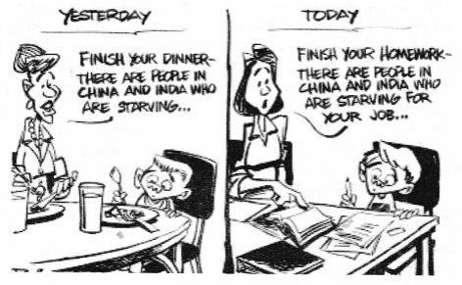
Study the picture and answer the questions that follow:

  - What does the image depict?
  - What is referred under the title ‘Yesterday’ ?
  - What message does the title ‘Today’ convey?

